Concepts
- Basic programming concepts – variables, types, constants, operators
- Control flow – if/else, switch, loops (for)
- Functions & parameters – passing by value, return values
- Error handling basics – returning errors, panic vs error
- Data structures – arrays, slices, maps, structs
- Pointers – basics, memory references, nil
- Strings and formatting – string operations, concatenation, formatting
- File I/O – reading/writing file
- Packages and modules – import, module management (go mod)
- Interfaces – abstraction, polymorphism
- Methods & receivers – struct methods, pointer vs value receivers
- Error handling patterns – wrapping, logging, errors.Is, errors.As
- Concurrency basics – goroutines, channels, select statements
- Defer, panic, recover – resource cleanup, graceful error recovery
- Testing in Go – unit tests, table-driven tests, test coverage
- Go formatting & linting – go fmt, golint, go ve
- Advanced concurrency – worker pools, fan-in/fan-out patterns
- Context package – cancellation, deadlines, timeouts
- Reflection – reflect package, dynamic typing
- Generics – writing reusable type-safe code
- Memory optimization – understanding slices, heap vs stack, pointers
- Profiling & benchmarking – pprof, benchmarks, memory and CPU profiling
- Error-resilient design – retry patterns, circuit breakers
- Database fundamentals – SQL, relational databases, transactions, joins
- Data modeling – ERD, normalization, constraints, indexes
- ORM & raw SQL in Go – GORM, sqlx, prepared statements
- Business logic architecture – separation of concerns, service layers, domain models
- Inventory & sales logic – stock in/out, returns, invoicing, tax calculations
- Financial accuracy – decimal arithmetic, rounding, multi-currency support
- Audit trails & logs – immutable logs for changes, accountability
- Reporting & analytics – aggregations, summaries, time-series calculations
- Modular architecture – packages, layered architecture
- API design – RESTful APIs, JSON, versioning
- Authentication & authorization – JWT, role-based access control
- Event-driven design – events, pub/sub patterns, message queues
- Concurrency-safe systems – locking, transactions, atomic operations
- Caching & optimization – in-memory caching, Redis, cache invalidation
- Error handling at scale – global error handling, monitoring, retries
- Microservices & services separation – when to split, communication patterns
- Scaling & load handling – horizontal scaling, load balancing, rate limiting
- Data consistency – ACID, eventual consistency, idempotency
- Fault tolerance – retries, fallbacks, replication
- Distributed systems basics – consensus, leader election, distributed transactions
- Security best practices – input validation, SQL injection prevention, encryption
- Testing at scale – integration tests, end-to-end tests, mocking services
- Continuous integration/deployment (CI/CD) – pipelines, testing, deployment strategies
- Monitoring & observability – metrics, logs, tracing
- Threat modeling – understanding potential attacks, mitigations
- Formal methods (optional, advanced) – reasoning about correctness, proving invariants
- Zero-downtime deployments – migrations, rolling updates, feature flags
- Performance tuning – profiling, concurrency optimization, memory leaks
- High availability systems – multi-region, failover strategies
- Eventual scaling – queue systems, batch processing, sharding
- Data migration & upgrade strategies – schema migrations without downtime
- Operational intelligence – log analysis, KPI tracking, automated anomaly detection
- Designing for “zero mistakes” – strong typing, immutability, safe patterns, code reviews

Day 1
Today it is 12.06.2025 it was yesterday I learned data types on go, like string, bool, int, float64 and stuffs and printed those using fmt. I couldn’t be able to do the project on topic 1, now im going to do it
Day 2
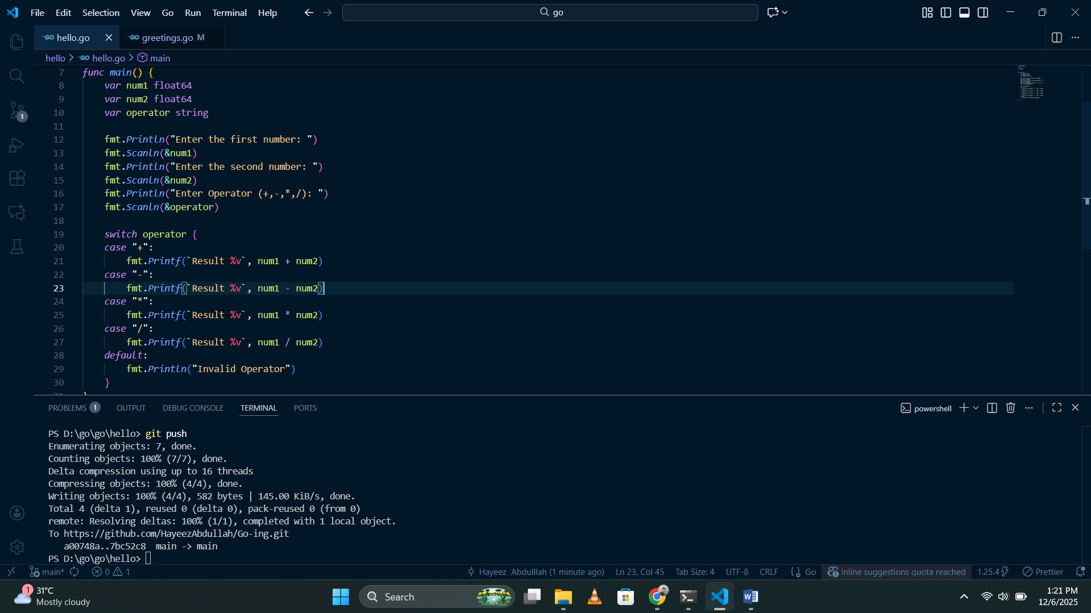
Today 12.06.2025 I made a calculator project, it simply takes two numbers as integer types and an operator as a string and performs the arithmetic operation according to the switch case function. I don’t think this is an effective program, because I typed the same code again and again for four times for each and every operation. Lets see what is the effective way.
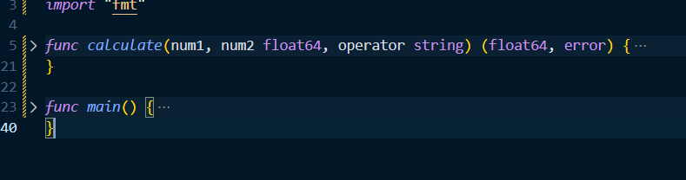
I asked chatgpt and figured out an effective way to program this function.
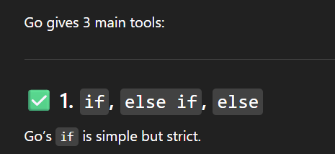
This one hits different as a nodejs developer to me. I don’t know what does “Go if is simple but strict”. Lets see…
Made a small program including if function, I understood why is it strict
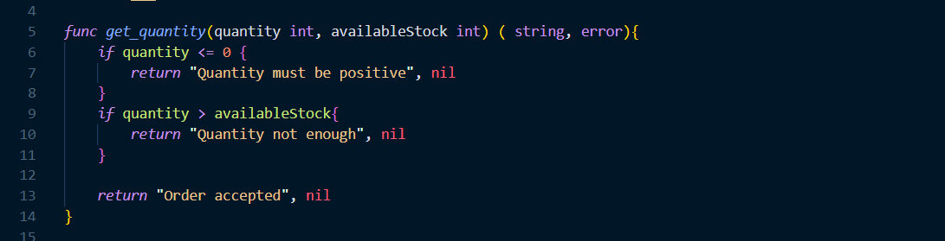
If we mention we are going to return two things, we must return those two if we fail to do that the program won’t run properly. It is better for proper error handling I guess, I have to study loops and build a full project with those later today I guess.
Day 3
Its 7th of December 2025, I guess I am going to learn if else and loops today, let’s see
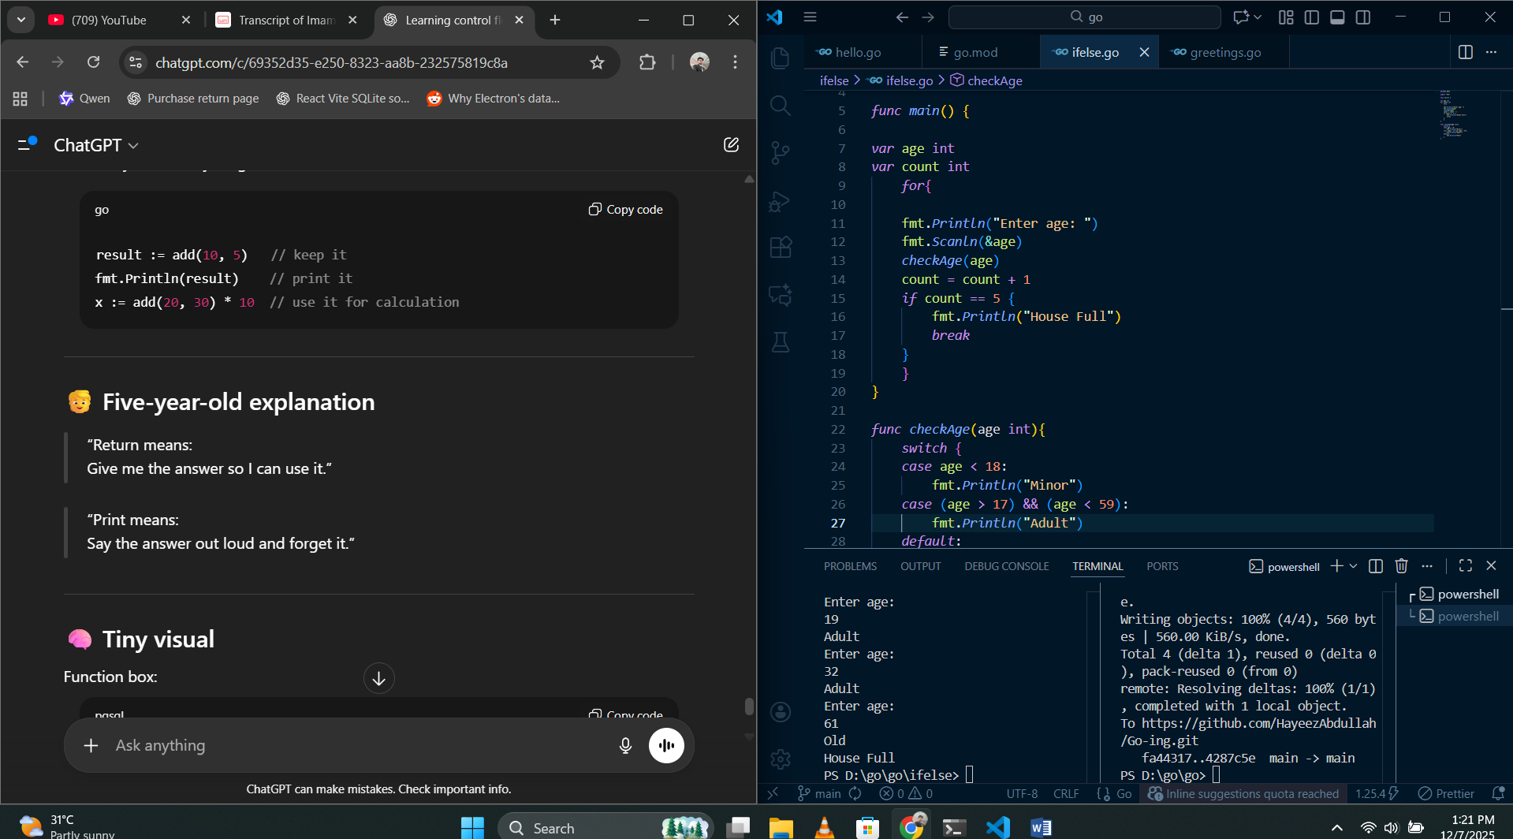
I learned switch case, if else, also the difference between using print function and return function.
Also, I learned functions and parameters.
Just now I asked ChatGPT what to learn to build a standard pos system, to get a good experience so it gave me some highlighted topics to learn first and then build the software.

Now I learned error handling, panic and errors a little bit so marked it in green aswell. Next I have to learn data structures. Let’s see
Its 9:51 PM same day, I opened my laptop and this document, I’m going to learn the next chapter which is Data structures.


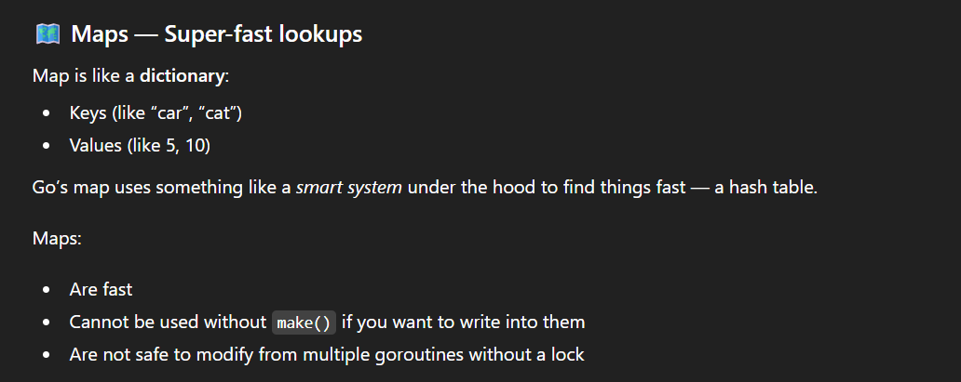
I learned Arrays and Slices, slices are different, it has some unique behaviors especially in GO
